Tokens

🧾 What Are Tokens in Web Development?
# Source: AI Source: Provided by: [Data Path: Persons Table -> ID Column: 1, Name_En Column: Motasem Essam] -> From: [ChatGPT] on [2/12/2026]
A token is a piece of data used to authenticate users and verify identity without storing session data on the server.
It is widely used in modern web apps and APIs.

✅ Simple Definition:
# Source: AI Source: Provided by: [Data Path: Persons Table -> ID Column: 1, Name_En Column: Motasem Essam] -> From: [ChatGPT] on [2/12/2026]
A token is a self-contained identity key that the client sends with each request to prove who they are.

🧠 Real-Life Analogy:
# Source: AI Source: Provided by: [Data Path: Persons Table -> ID Column: 1, Name_En Column: Motasem Essam] -> From: [ChatGPT] on [2/12/2026]
Think of a token like a boarding pass:
● You get it after login
● It contains your info
● You show it every time (requests)
● It expires after some time

🔁 How Tokens Work
# Source: AI Source: Provided by: [Data Path: Persons Table -> ID Column: 1, Name_En Column: Motasem Essam] -> From: [ChatGPT] on [2/12/2026]
- 👤 User logs in with credentials
- 🧠 Server verifies user
- 🔐 Server generates a token (JWT)
- 📦 Token is sent to the client
- 💾 Client stores token (cookie / localStorage)
- 🔁 Token is sent with every request
- ✅ Server verifies token and allows access

🧬 Structure of JWT
# Source: AI Source: Provided by: [Data Path: Persons Table -> ID Column: 1, Name_En Column: Motasem Essam] -> From: [ChatGPT] on [2/12/2026]
A JWT consists of 3 parts:
xxxxx.yyyyy.zzzzz

1. 🧾 Header
# Source: AI Source: Provided by: [Data Path: Persons Table -> ID Column: 1, Name_En Column: Motasem Essam] -> From: [ChatGPT] on [2/12/2026]
● Algorithm (HS256)
● Type (JWT)

2. 📦 Payload
# Source: AI Source: Provided by: [Data Path: Persons Table -> ID Column: 1, Name_En Column: Motasem Essam] -> From: [ChatGPT] on [2/12/2026]
● user_id
● username
● role
● exp (expiration time)

3. 🔐 Signature
# Source: AI Source: Provided by: [Data Path: Persons Table -> ID Column: 1, Name_En Column: Motasem Essam] -> From: [ChatGPT] on [2/12/2026]
● Ensures token is not tampered with

📤 How Token Is Sent
# Source: AI Source: Provided by: [Data Path: Persons Table -> ID Column: 1, Name_En Column: Motasem Essam] -> From: [ChatGPT] on [2/12/2026]
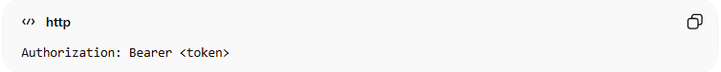
Authorization: Bearer <token>

📦 Where Tokens Are Stored
# Source: AI Source: Provided by: [Data Path: Persons Table -> ID Column: 1, Name_En Column: Motasem Essam] -> From: [ChatGPT] on [2/12/2026]
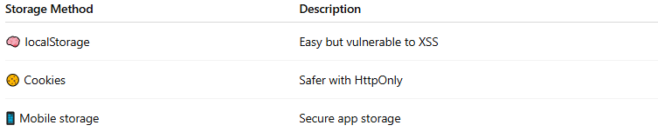
Storage Method | Description
🧠 localStorage | Easy but vulnerable to XSS
🍪 Cookies | Safer with HttpOnly
📱 Mobile storage | Secure app storage

💻 Example in PHP
# Source: AI Source: Provided by: [Data Path: Persons Table -> ID Column: 1, Name_En Column: Motasem Essam] -> From: [ChatGPT] on [2/12/2026]
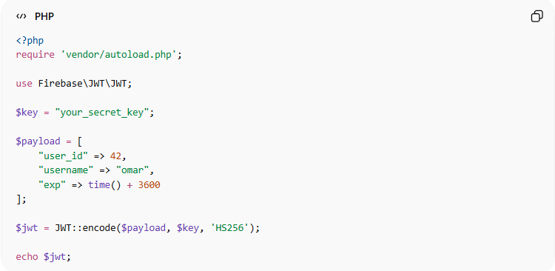
<?php
require 'vendor/autoload.php';

use Firebase\JWT\JWT;

$key = "your_secret_key";

$payload = [
"user_id" => 42,
"username" => "omar",
"exp" => time() + 3600
];

$jwt = JWT::encode($payload, $key, 'HS256');

echo $jwt;
● JWT::encode() creates the token
● Payload contains user data and expiration
● Token is signed with a secret key
● Token is sent to the client

⚔️ Token vs Session ID
# Source: AI Source: Provided by: [Data Path: Persons Table -> ID Column: 1, Name_En Column: Motasem Essam] -> From: [ChatGPT] on [2/12/2026]
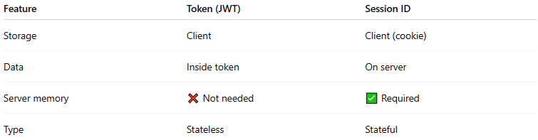
Feature | Token (JWT) | Session ID
Storage | Client | Client (cookie)
Data | Inside token | On server
Server memory | ❌ Not needed | ✅ Required
Type | Stateless | Stateful

⚡ Stateless Concept
# Source: AI Source: Provided by: [Data Path: Persons Table -> ID Column: 1, Name_En Column: Motasem Essam] -> From: [ChatGPT] on [2/12/2026]
● Server does NOT store session data
● Each request contains all required info
● Improves scalability and performance

⌛ Token Expiration
# Source: AI Source: Provided by: [Data Path: Persons Table -> ID Column: 1, Name_En Column: Motasem Essam] -> From: [ChatGPT] on [2/12/2026]
Common fields:
● exp → expiration time
Typical usage:
● Access token → short-lived (minutes)
● Refresh token → long-lived (days)

🔄 Access Token vs Refresh Token
# Source: AI Source: Provided by: [Data Path: Persons Table -> ID Column: 1, Name_En Column: Motasem Essam] -> From: [ChatGPT] on [2/12/2026]
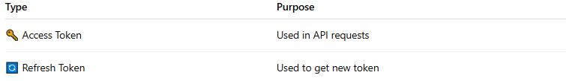
Type | Purpose
🔑 Access Token | Used in API requests
🔄 Refresh Token | Used to get new token

🛡️ Security Tips
# Source: AI Source: Provided by: [Data Path: Persons Table -> ID Column: 1, Name_En Column: Motasem Essam] -> From: [ChatGPT] on [2/12/2026]
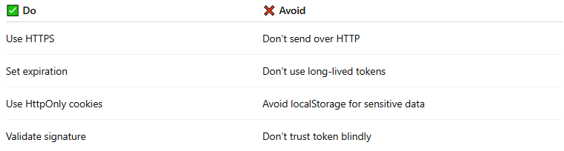
✅ Do | ❌ Avoid
Use HTTPS | Don’t send over HTTP
Set expiration | Don’t use long-lived tokens
Use HttpOnly cookies | Avoid localStorage for sensitive data
Validate signature | Don’t trust token blindly

🧠 When to Use Tokens
# Source: AI Source: Provided by: [Data Path: Persons Table -> ID Column: 1, Name_En Column: Motasem Essam] -> From: [ChatGPT] on [2/12/2026]
Use tokens when:
● Building APIs
● Mobile applications
● Microservices
● Need high scalability

🎓 Final Mental Model
# Source: AI Source: Provided by: [Data Path: Persons Table -> ID Column: 1, Name_En Column: Motasem Essam] -> From: [ChatGPT] on [2/12/2026]
👉 Token = Identity card (self-contained)
👉 Server does NOT store your data
👉 Every request proves who you are

